Education provider and / or programme concern notification form

Purpose of this form
This form should be used to formally raise concerns about education provider and / or programme(s). We appreciate that it can be difficult to raise concerns, and so want to ensure you understand our remit in what we can and cannot investigate.

We can consider concerns that:
- Relate to a programme on our approved list
- May impact on our education standards being met by the provider / programme.

We cannot consider concerns that fall out of this remit. For example, we cannot require education providers to change their decisions relating to academic judgement or otherwise.

Process stage diagram
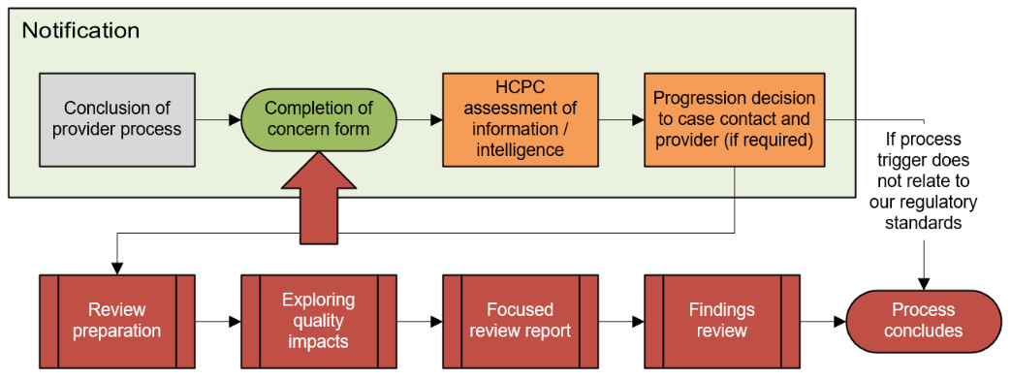

Step by step guidance
- You complete all sections of this form, with as much detail as possible to help us understand your concerns
- You collate any supporting documentation that you consider could be useful to our investigation
- You submit the completed form plus any supporting information to education@hcpc-uk.org

Continuing process – next steps and key milestones
- We review the information you have sent, and respond with a decision about whether we will investigate within two weeks
- If we decide to investigate:
  - We may ask you for further information to help with our investigation
  - We will work with the education provider, and ask them for information where needed
  - We will provided a recommendation on next steps through a report
  - You and the provider will have the opportunity to comment on this report by supplying ‘observations’
  - Our Education and Training Committee will decide on next steps, considering the report and any observations submitted

Concern information

Section 1 – Your details
We ask those that raise concerns to identify themselves, as it is helpful for all parties to know who has raised a concern. This allows:
- us to properly investigate, including asking for further evidence / information (where required):
- us to clarify our understanding of issues;
- us to signpost you elsewhere if potential issues fall outside of our remit; and
- education providers to understand the context when providing a response.
Name
Relationship to the programme | Choose an item.  Please provide any comments here:
Telephone number
Email address

Section 2 – Programme details
Please check details of the programme on the register of approved programmes when completing this section. This enables us to ensure we are responsible for monitoring the programme.
Name of education provider
Programme name (please leave this line blank if you concern does not relate to a specific programme at the provider)
Mode(s) of study | Full time  Full time accelerated | Part time  Distance learning | Work based learning  Flexible

Section 3 – Details of your concern
We can only consider concerns that may impact on our education standards being met by the provider and / or programme. We cannot require education providers to change their decisions, relating to academic judgement or otherwise.

If your concern relates to academic judgement or an individual’s fitness for an academic award, you should raise your concern via the education provider’s internal appeals process.
Which of these areas best describe your concern?  (Please tick all that apply)  Academic judgement  An individual’s fitness for an academic award  Issues with how our education standards are met |  | What area(s) of the programme do your concerns relate to?  Programme admissions  Programme governance, management and leadership  Programme design and delivery  Practice-based learning  Assessment
What would you like to happen because of an HCPC investigation?
We ask that you attempt to resolve any concerns you have directly with the education provider before we will progress to an investigation. As HCPC-approved programmes meet our standards, we have judged that there is “a thorough and effective process in place for receiving and responding to learner complaints”.
Have you formally raised your concern(s) with the education provider? | Yes  No
Has the investigation concluded? | Yes  No
What was the outcome of their investigation?
Have you raised your concern(s) with any other body or institution? | Yes  No  If you have answered ‘yes’, please note which institution(s):
What were the outcome(s) of their investigation(s)? | Investigation not concluded  Or please state outcome:
Do your concern(s) also relate to the fitness to practise of HCPC registrant(s)? | Yes  No  If you have answered ‘yes’, you will need to raise a separate concern via our fitness to practise process. We will also refer this concern internally to our Fitness to Practise team.

Please provide details of your concern(s)
We are only able to investigate concerns that link to how programmes meet our education standards. Therefore, please link your concern(s) to at least one of the following areas:
- Programme admissions – relating to the admissions processes for the programme
- Programme governance, management and leadership – relating to how the programme is led, managed and governed, including:
  - the processes for monitoring and reviewing the programme;
  - involving stakeholders; and
  - making sure that necessary resources are available to learners and educators.
- Programme design and delivery – how the programme ensures that learners who complete the programme are fit to practise.
- Practice-based learning – relating to clinical or practical experience that forms part of the programme. How the education provider:
  - approves and monitors practice-based learning to make sure it is effective;
  - keeps service users, learners and others safe;
  - provides adequate resources and support; and
  - provides necessary information to learners and practice educators.
- Assessment – how learners are assessed through the programme, particularly how learners meet the requirements of the programme and our proficiency standards.
Please list any supporting evidence that you have provided along with this form

Section 4 – Consent to investigate
I would like the HCPC to investigate my concern. I understand that:
- The HCPC will decide whether my concern can be investigated
- If the HCPC decides to investigate, they will send a copy of this programme concern notification form and any supporting evidence to the education provider; and
- I must inform you immediately if any part of my concern is being dealt with by another body.
Name: | Date: Click or tap to enter a date.
PLEASE NOTE
- By completing the above information, you acknowledge that the HCPC may contact these individuals regarding quality assurance activities. We request and handle any personal data received in accordance with our Data and Terms of Use Policy.
- At relevant points, we will actively share information from quality assurance activities with other relevant organisations with an interest in the quality of education and training, including, but not limited to, professional and commissioning bodies.
The HCPC is subject to the Freedom of Information Act 2000 (FOIA), which provides a general right of public access to recorded information held by public authorities. The information which we may be required to make available under FOIA includes correspondence and other information about our quality assurance activity. If you indicate that information is provided in confidence, we will take that into account in dealing with any request for disclosure of that information, but cannot give an assurance that confidentiality will be maintained in all circumstances. A statutory Code of Practice under FOIA deals with confidentiality obligations and we must comply with that Code. We do not regard confidentiality disclaimers which are automatically generated by IT systems as binding on the HCPC.
Once completed, please return this form to education@hcpc-uk.org

